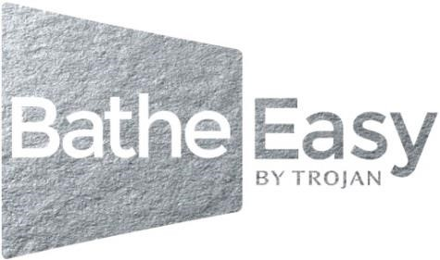

Thank you for ordering a Bathe Easy bath.
Comfort 1210x660mm
C/w 1 x Front Panel, 1 x End Panel & Twin wastes
In order to process your order, we have created a checklist.
We ask that you complete this form and return it to our offices so that we can process the order for dispatch.

Please confirm the items required by placing an “X” in the boxes below
Note: The baths are handed by the access door position.
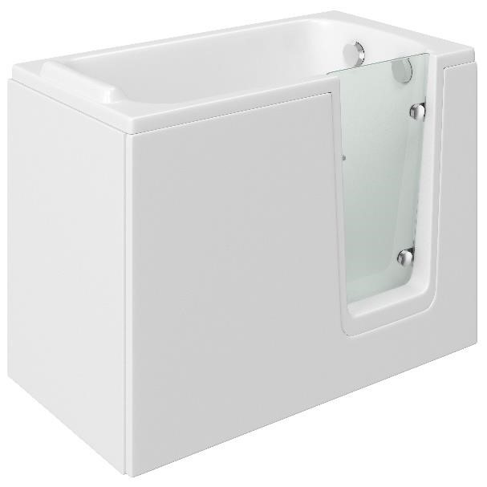
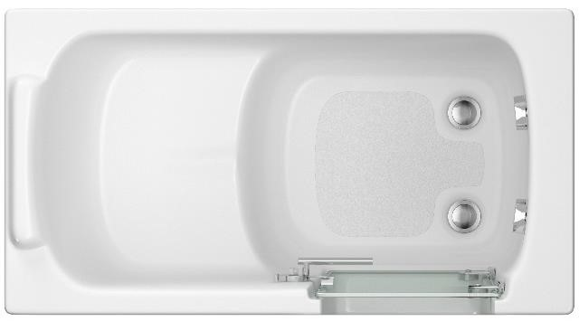
Right
-

handed bath

E0020

-

1210x660
RH

12 JET AIRSPA SYSTEM
N0086 – Compact Rectangular Shower Screen 1150H

Left
–

handed bath

E0019

–

1210x660
LH

Optional Extra
s
:

Delivery Address: Showroom End User

_ _ _ _ _ _ _ _ _ _ _ _ _ _ _ _ _ _ _ _ _ _ _ _ _ _ _ _ _ _ _ _ _ _ _ _ _ _ _ _ _ _ _ _ _ _ _ _ _ _ _ _ _ _ _ _ _ _ _ _ _ _ _ _ _ _

_ _ _ _ _ _ _ _ _ _ _ _ _ _ _ _ _ _ _ _ _ _ _ _ _ _ _ _ _ _ _ _ _ _ _ _ _ _ _ _ _ _ _ _ _ _ _ _ _ _ _ _ _ _ _ _ _ _ _ _ _ _ _ _ _ _

_ _ _ _ _ _ _ _ _ _ _ _ _ _ _ _ _ _ _ _ _ _ _ _ _ _ _ _ _ _ _ _ _ _ _ _ _ _ _ _ _ _ _ _ _ _ _ _ _ _ _ _ _ _ _ _ _ _ _ _ _ _ _ _ _ _

Postcode: _ _ _ _ _ _ _ _ _ _ _ _ _ _ _ _ _ _ _ _ _ _ _ _ _ _

Before you complete your purchase,

Please note: This is a Special Order Product item

If a bath is delivered and it is found that the wrong hand or size was ordered, we reserve the right to invoice £120.00 + VAT to arrange for the bath to be returned to Trojan.

The goods must be returned in full working order and as new and they must be returned in their original packaging. Failure to do so will result in an additional re-work charge of £50.00 + VAT

The items above are specially ordered, you can only cancel an order prior to it being dispatched.

If we dispatch the product and delivery of the product is refused at point of delivery you will be charged a £120.00 + VAT handling & restocking charge.

If the bath is ordered with an Air Spa System, it cannot be cancelled or returned.

We are unable to accept the items back that have been fitted, damaged or have been subjected to abuse.

Special Orders will have to have a signed form from customer agreeing to the Terms & Conditions of the Special Order outlined above. This does not affect the guarantee

Please note: Pallet deliveries are to the Kerbside only. Delivery drivers are only able to deliver pallets to as close as possible to the exterior of the property's front door or driveway.
Please ensure you have ordered the correct hand of bath.

I confirm I have read and agree to the above,

Signed: …………………………………………………………………………………………….

Date: …………………………………………………………………………………………………….

